Interview

Pau from Oh my Dior!
LUX by LuxBox Case

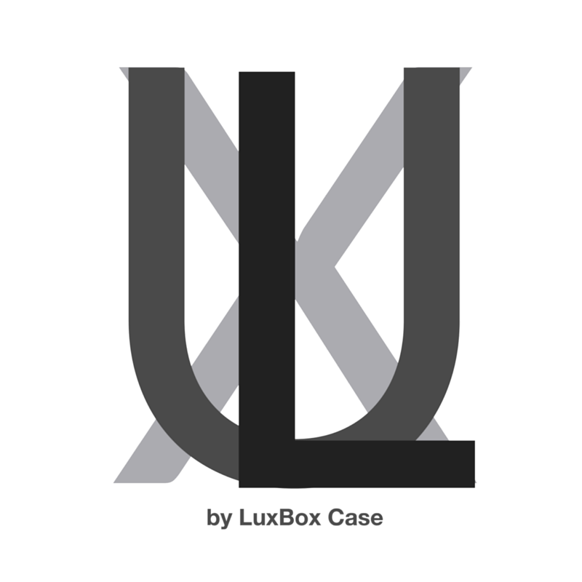
Name: Pauline
Age (optional):
Location (city/state/country): Mexico

* From here on if you find it easier you can dictate the answers to these questions just to make it a lot easier or more convenient for you. You can do this either by dictating on Siri or https://dictation.io/ (can only be used on chrome desktop browser but HIGHLY RECOMMENDED)!), or you can simply dictate an audio note on your phone and emailed us that audio note.

In your own words, as if you were telling a friend you haven't seen in years, how would you describe what it is that you do as it pertains to blogging, fashion, and influence?
It’s a really fun job and although I love fashion I also love to spread positive messages to people. It’s amazing to know that you are influencing others to become their great version not just having great style. Also I love how many trips and events you are invited to, you start knowing many interesting people too.

When did you first get really interested and passionate about fashion and style?
Since I was little I was passionate about fashion. I remember that I got really upset with my mother every time she didn’t let me choose my outfit. Since I was three years old I love experimenting with different styles but I never imagined that I will become a fashion blogger. Everything happened by accident.

How do you describe your personal style?
My personal style changes a lot. I’m not the girl who dresses the same everyday, you can see it by how often I dye my hair. I love experimenting with different styles and personalities, I think as a human being you should try everything, not to find yourself but to find different parts of yourself. That’s the beauty of contrasts.

What was the impetus to get you started on this journey?
I didn’t know that this will be my future job. Everything started in Barcelona I was living there, studying there and had a lot of free time. When I was there the first bloggers started to appear in the spotlight and I admire the a lot. So I decided to create a blog to imitate them but at first I didn’t want anyone to see my blog it was just for me. Like a diary from my time spent to Barcelona but suddenly people found me and started following me.

Tell me about your childhood, is there anything about your childhood, upbringing, or family history that you can link to your inspiration today?
I think everything because all is connected. Every experience and every people you met leave you with something. But maybe what made me realize how much I love making editorial content was working in a Fashion magazine, it was really fun to plan the photoshoots and choose the clothes.

Think about the 80/20 rule; if you get 80% of your impact from 20% of what you do, what is that 20% for you as it pertains to developing and expressing your personal style?
I think that something that got me where I am today is to be authentic, I’m always sharing honest with my followers never pretending to be someone I’m not. I expose myself with my flaws, my problems, my sickness and heart breaks. I think the audience like genuine people with whom they can relate to.

What about discovering new styles to incorporate into your look and style?
I do it all the time. Sometimes you get inspired by magazines, movies, models or someone you just met and for me it makes me want to try everything. I have changed my style from bohemian to classic to minimal to fashion victim to dark. I think I have been trying everything, it’s really fun.

Who do you consider the icons in the fashion & design industry?
I don’t believe a lot in fashion icons, I think that there are so many different personalities and body types that we have variety. That’s one of the few good things about fast fashion that they just don’t cover one trend they offer you variety; different styles depending in the mood. I know that many people still follow trends but many people aren’t too, they are trying to find themselves. No matter if they are in a 80s outfit or dressed up like a gothic princess.

What's the next frontier in building your tribe?
AsI have said it all started as a fashion blogger but now I define myself most as a lifestyle blogger. I have a really peculiar way of living, since many years ago I feel too connected with the Universe and I’m always trying to bring magic to my life. The more I share my way of seeing the world the more people follow me.

What’s next? & why?
I want to create a mind institute, a place where I can create services and products that can make people’s lives better. Especially now, that I consider we are starting a new era where we are realizing that we are more than a human, we are vibratory energy beings. I will love to take advantage of my audience and start creating this project that probably will start with a book.

What are you reading these days?
All the time, I’m really fan of Quantum Physics, Spirituality and The Law of Attraction. Recently I read the book “The Vortex” by Abraham Hicks. It’s a really interesting book that talks about how the law of attraction and what we think influences the way people act with you or treat you.

What are your 3 essential productivity tools, how do you use them, and why do you love them?
Of course I love social media especially facebook where I got more than 2.5 million followers, for me it’s the easiest way to make something viral. Also my phone, I don’t really need a camera this days I try to capture everything with it. And last my computer which helps me to do different designs for the messages I put on my blog or to retouch y photos.

What style/fashion accessory is your favorite?
I love all the accessories, for me they are much more important that clothes because they give your outfit the personality. I’m really into bag, shoes, hats and jewelry. I feel naked without accessories.

If you can/could consider yourself an expert in one area of style/fashion, what would it be?
Fashion Marketing, I find really interesting to know how to sell brands, especially luxury ones. I think that’s the coolest skill to influence people. Of course I’ll use it for good purposes not just to sell products.
Can you give me a tutorial on how people can best incorporate that style/fashion advice in their life?
I think that to have a great style you need two things:

One is to develop your “eye skills”. Start seeing movies, muses, art everything that can inspire you. The more good photos or images you see the more great state you’ll develop.

And

Two know yourself, believe in you and your decisions no matter what other people tell you. Only wear what makes you comfortable and love yourself. Try to be someone confident, that’s the best ingredient for having style.

What are your favorite local spots to:
  - Grab a quick, healthy meal?
  - Workout outdoors?
  - Enjoy nature?
  - See art?
  - Have a cup of tea or coffee?
I love cool places to grab some coffee with my friends or by myself. I also love music concerts and art exhibitions, when I’m there I feel really inspired. And to travel and find new spotlights is the best in life.

In addition to yourself, whom should we follow on Instagram?
I’m not sure, I don’t have names on my mind. I’m the kind of person that starts following a lot of people just because I like something they’ve got. I’m following people around the world but I really have a crush on Russian Girls like Sonya Esman.

Is there anything else you’d like to add?

Website: http://www.ohmydior.org/

Instagram: sheismagique

Twitter: ohmydiorblog

SnapChat: sheismagique

* Please attach 8-10 high res lifestyle images that reflect your personality and brand. Please feel free to use images you already have.

To make the feature visually pleasing, I'm kindly requesting to be supplied with five to eight pictures. Keep in mind that the photos should be aesthetically pleasing and add to the story.

Please let me know who to credit for these images.

Here are some example images to illustrate what we’re looking for:

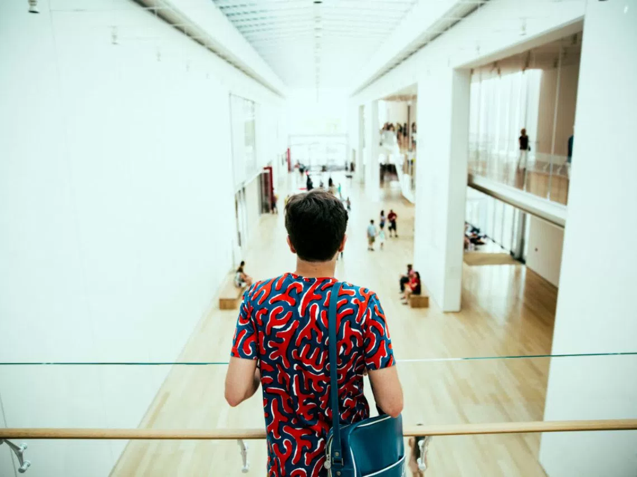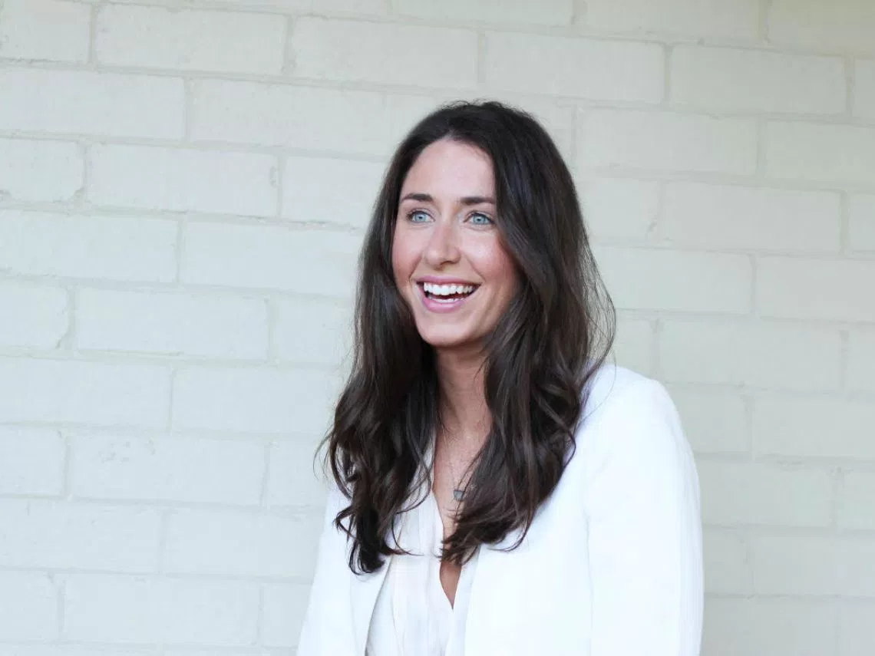
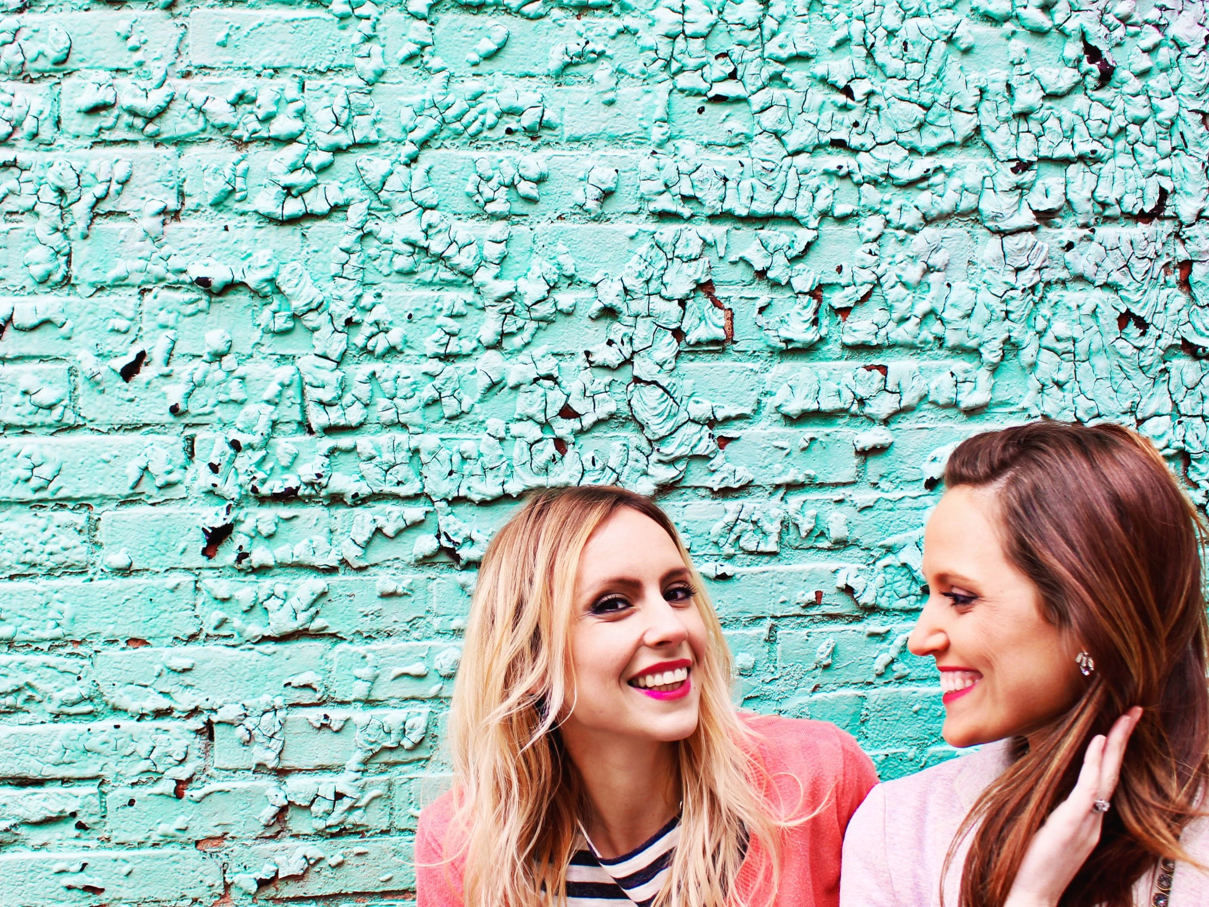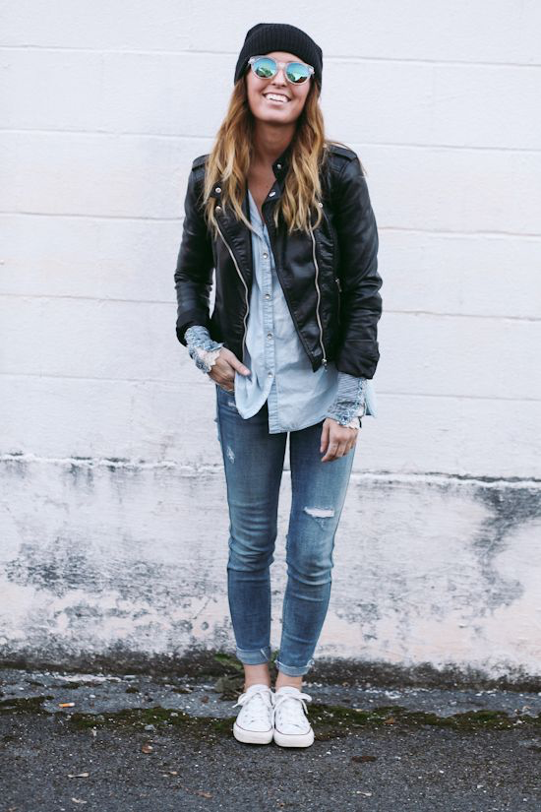
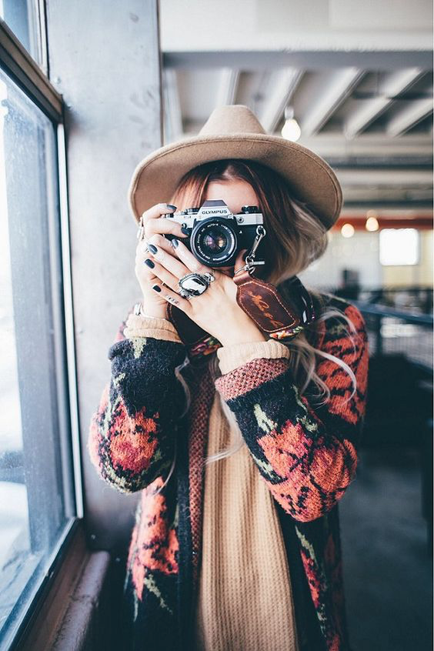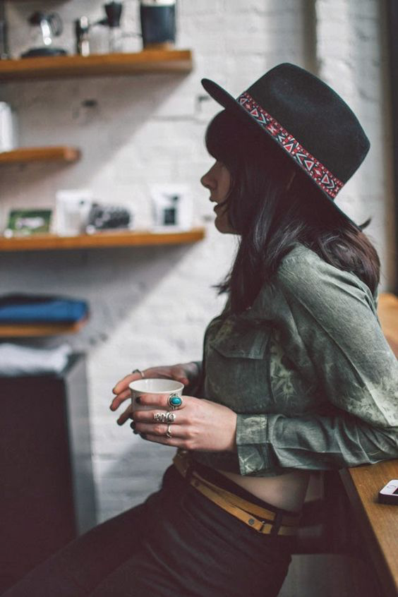

* We’d love to have some video shorts that can enhance the digital publication experience

Feel free to share any questions or concerns you may have.

Keith

